Data: TTS
Método de validación: Hold – Out 70 – 30
Modelo: XGBoost

Resultados CON variables de Locación
METRIC | Non-spatial |  | Queen |  | Knn
 | Training | Test | Training | Test | Training | Test
RMSE | 0.02475 | 0.08695 | 0.03646 | 0.07694 | 0.0352 | 0.07932
Pearson Correlation | 0.97179 | 0.29933 | 0.93505 | 0.42044 | 0.93718 | 0.40237
Spearman_ Correlation | 0.90479 | 0.53015 | 0.85189 | 0.57824 | 0.85001 | 0.63459
Standar deviation | 0.02476 | 0.08649 | 0.03647 | 0.07676 | 0.03521 | 0.07896

Resultados SIN variables de Locación
METRIC | Non-spatial |  | Queen |  | Knn
 | Training | Test | Training | Test | Training | Test
RMSE | 0.01515 | 0.07941 | 0.02267 | 0.07683 | 0.002 | 0.08307
Pearson Correlation | 0.99059 | 0.37132 | 0.97826 | 0.41717 | 0.99979 | 0.39167
Spearman_ Correlation | 0.9568 | 0.56475 | 0.9198 | 0.58021 | 0.99848 | 0.57679
Standar deviation | 0.01516 | 0.07901 | 0.02268 | 0.07665 | 0.002 | 0.0824

Data: Phone 05
Método de validación: Hold – Out 70 – 30
Modelo: XGBoost

Resultados CON variables de Locación
METRIC | Non-spatial |  | Queen |  | Knn
 | Training | Test | Training | Test | Training | Test
RMSE | 0.000530 | 0.00145 | 0.00047 | 0.00147 | 0.00064 | 0.00147
Pearson Correlation | 0.98552 | 0.88468 | 0.9887 | 0.88051 | 0.97891 | 0.88067
Spearman_ Correlation | 0.96898 | 0.87248 | 0.9744 | 0.86928 | 0.95838 | 0.87111
Standar deviation | 0.000530 | 0.00145 | 0.00047 | 0.00147 | 0.00064 | 0.00147

Resultados SIN variables de Locación
METRIC | Non-spatial |  | Queen |  | Knn
 | Training | Test | Training | Test | Training | Test
RMSE | 0.0004 | 0.00146 | 0.0004 | 0.00146 | 0.000470 | 0.00145
Pearson Correlation | 0.99174 | 0.88213 | 0.99193 | 0.88251 | 0.98862 | 0.88479
Spearman_ Correlation | 0.98086 | 0.8776 | 0.98096 | 0.87704 | 0.9738 | 0.87689
Standar deviation | 0.0004 | 0.00146 | 0.0004 | 0.00146 | 0.000470 | 0.00145

MODELO DE REGRESIÓN LINEAL MÚLTIPLE (Experimento pedido por Carmen)
Data: TTS
Método de validación: Hold – Out 70 – 30
Modelo: Regresiòn Lineal Multiple

Resultados CON variables de Locación
METRIC | Non-spatial |  | Queen |  | Knn
 | Training | Test | Training | Test | Training | Test
RMSE | 0.082 | 0.078 | 0.079 | 0.076 | 0.079 | 0.073
Pearson Correlation | 0.443 | 0.338 | 0.509 | 0.386 | 0.515 | 0.454
Spearman_ Correlation | 0.631 | 0.538 | 0.667 | 0.555 | 0.675 | 0.593
Standar deviation | 0.082 | 0.077 | 0.079 | 0.076 | 0.079 | 0.073

Resultados SIN variables de Locación
METRIC | Non-spatial |  | Queen |  | Knn
 | Training | Test | Training | Test | Training | Test
RMSE | 0.082 | 0.078 | 0.079 | 0.076 | 0.079 | 0.073
Pearson Correlation | 0.439 | 0.334 | 0.506 | 0.384 | 0.514 | 0.456
Spearman_ Correlation | 0.629 | 0.54 | 0.667 | 0.558 | 0.674 | 0.597
Standar deviation | 0.083 | 0.078 | 0.079 | 0.076 | 0.079 | 0.073

Data: TTS
Método de validación: Blocked CV
Modelo: XGBoost

Resultados CON variables de Locación
METRIC | Non-spatial |  | Queen |  | Knn
 | Training | Test | Training | Test | Training | Test
RMSE
Pearson Correlation
Spearman_ Correlation
Standar deviation

Resultados SIN variables de Locación
METRIC | Non-spatial |  | Queen |  | Knn
 | Training | Test | Training | Test | Training | Test
RMSE | 0.014 | 0.088 | 0.013 | 0.085 | 0.019 | 0.078
Pearson Correlation | 0.99 | 0.272 | 0.991 | 0.324 | 0.981 | 0.427
Spearman_ Correlation | 0.955 | 0.433 | 0.958 | 0.472 | 0.932 | 0.574
Standar deviation | 0.014 | 0.088 | 0.013 | 0.085 | 0.019 | 0.078

Data: Phone 05
Método de validación: Blocked CV
Modelo: XGBoost

Resultados CON variables de Locación
METRIC | Non-spatial |  | Queen |  | Knn
 | Training | Test | Training | Test | Training | Test
RMSE
Pearson Correlation
Spearman_ Correlation
Standar deviation

Resultados SIN variables de Locación
METRIC | Non-spatial |  | Queen |  | Knn
 | Training | Test | Training | Test | Training | Test
RMSE | 0 | 0.002 | 0 | 0.002 | 0 | 0.002
Pearson Correlation | 0.991 | 0.829 | 0.99 | 0.845 | 0.989 | 0.848
Spearman_ Correlation | 0.979 | 0.844 | 0.981 | 0.855 | 0.976 | 0.845
Standar deviation | 0 | 0.002 | 0 | 0.002 | 0 | 0.002

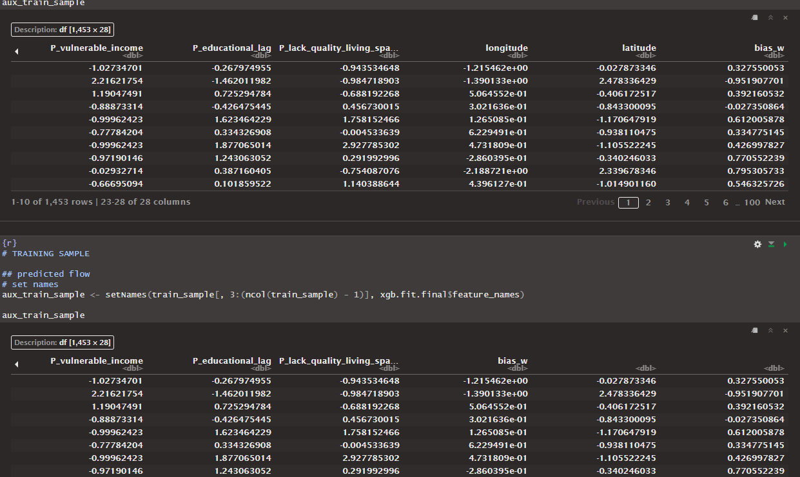
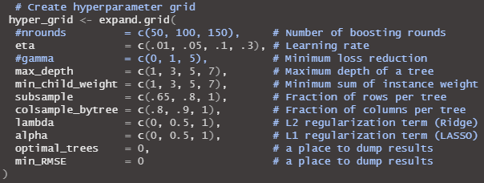
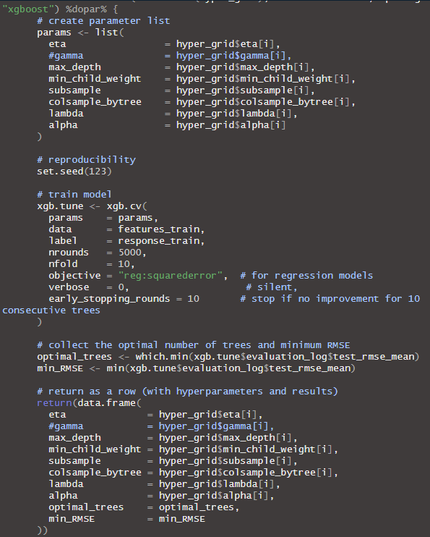
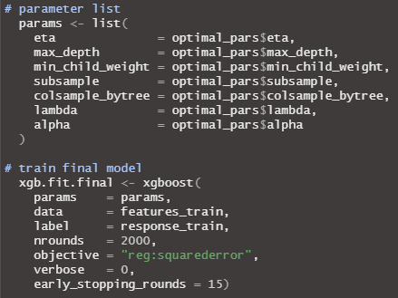

Data: TTS
Validation Method: Hold – Out 70 – 30
Model: XGBoost
Location: NO
Gamma:NO
Grid Search:5184
PARALLELISED CODE
nrounds: 5000
early_stopping_rounds :10
TRAIN FINAL MODEL
nrounds: 2000
early_stopping_rounds :15

METRIC | Non-spatial |  | Queen |  | Knn
 | Training | Test | Training | Test | Training | Test
RMSE | 0.015 | 0.082 | 0.023 | 0.077 | 0.002 | 0.080
Pearson Correlation | 0.990 | 0.340 | 0.978 | 0.398 | 1.000 | 0.414
Spearman_ Correlation | 0.955 | 0.565 | 0.917 | 0.577 | 0.999 | 0.606
Standar deviation | 0.015 | 0.081 | 0.023 | 0.077 | 0.002 | 0.080
r squared | 0.972 | -0.007 | 0.938 | 0.096 | 1.000 | 0.028

RMSE: ¿Cuánto se equivoca la predicción?
R squared: ¿Qué tan bien el modelo explica los datos?
Pearson / Spearman: ¿Qué tan bien la dirección de las predicciones sigue la dirección de los datos reales (lineal o monotónica)?
Standard deviation: ¿Qué tan dispersos están los datos o errores?

 | eta | max_depth | min_child_weight | subsample | colsample_bytree | lambda | alpha | optimal_trees | min_RMSE
N | 0.05 | 7 | 7 | 0.65 | 0.8 | 0 | 0.5 | 160 | 0.07847803
Q | 0.1 | 7 | 7 | 1 | 0.9 | 1 | 0.5 | 70 | 0.07698234
K | 0.1 | 3 | 5 | 1 | 0.8 | 0 | 0 | 70 | 0.07468862

Data: Phone 05
Validation Method: Hold – Out 70 – 30
Model: XGBoost
Location: NO
Gamma:NO
Grid Search:5184
PARALLELISED CODE
nrounds: 5000
early_stopping_rounds :10
TRAIN FINAL MODEL
nrounds: 2000
early_stopping_rounds :15

METRIC | Non-spatial |  | Queen |  | Knn
 | Training | Test | Training | Test | Training | Test
RMSE | 0.000 | 0.001 | 0.000 | 0.001 | 0.000 | 0.001
Pearson Correlation | 0.992 | 0.883 | 0.992 | 0.882 | 0.988 | 0.886
Spearman_ Correlation | 0.981 | 0.876 | 0.981 | 0.875 | 0.973 | 0.879
Standar deviation | 0.000 | 0.001 | 0.000 | 0.001 | 0.000 | 0.001
r squared | 0.983 | 0.779 | 0.984 | 0.778 | 0.976 | 0.784

 | eta | max_depth | min_child_weight | subsample | colsample_bytree | lambda | alpha | optimal_trees | min_RMSE
N | 0.01 | 7 | 3 | 0.65 | 0.8 | 0 | 0 | 907 | 0.00137982
Q | 0.01 | 7 | 3 | 0.65 | 0.8 | 0 | 0 | 925 | 0.00131721
K | 0.01 | 5 | 3 | 0.8 | 0.8 | 0 | 0 | 894 | 0.00132756

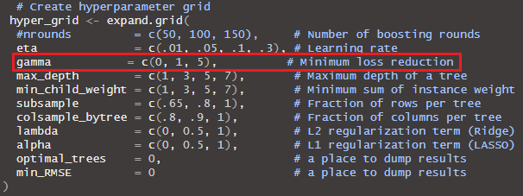
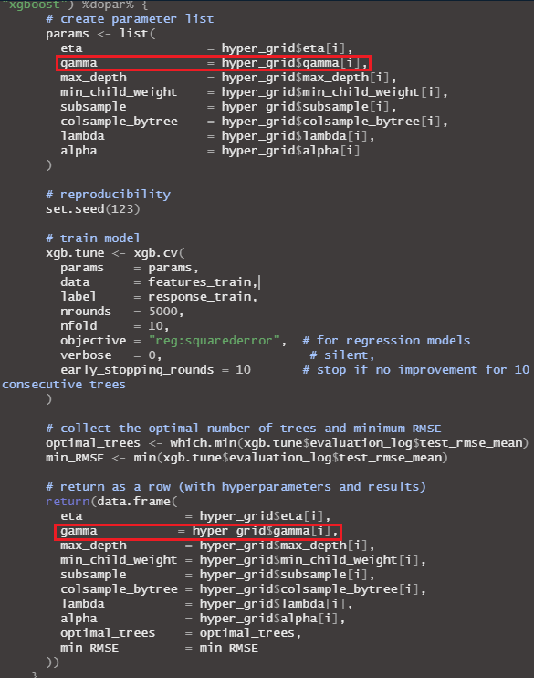
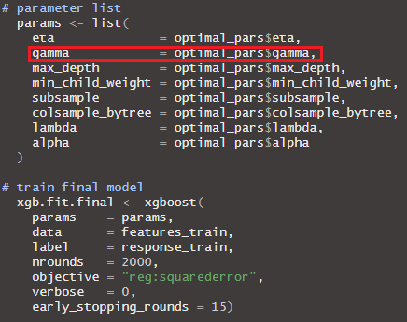

Data: TTS
Validation Method: Hold – Out 70 – 30
Model: XGBoost
Location: NO
Gamma: SI
Grid Search: 15,552
PARALLELISED CODE
nrounds: 5000
early_stopping_rounds :10
TRAIN FINAL MODEL
nrounds: 2000
early_stopping_rounds :15

METRIC | Non-spatial |  | Queen |  | Knn
 | Training | Test | Training | Test | Training | Test
RMSE | 0.015 | 0.081 | 0.023 | 0.077 | 0.002 | 0.080
Pearson Correlation | 0.990 | 0.344 | 0.978 | 0.398 | 1.000 | 0.414
Spearman_ Correlation | 0.958 | 0.568 | 0.917 | 0.577 | 0.999 | 0.606
Standar deviation | 0.015 | 0.081 | 0.023 | 0.077 | 0.002 | 0.080
r squared | 0.972 | 0.011 | 0.938 | 0.096 | 1.000 | 0.028

 | eta | gamma | max_depth | min_child_weight | subsample | colsample_bytree | lambda | alpha | optimal_trees | min_RMSE
N | 0.05 | 0 | 7 | 7 | 0.65 | 0.8 | 0 | 0.5 | 160 | 0.07847803
Q | 0.1 | 0 | 7 | 7 | 1 | 0.9 | 1 | 0.5 | 70 | 0.07698234
K | 0.1 | 0 | 3 | 5 | 1 | 0.8 | 0 | 0 | 70 | 0.07468862

Data: Phone 05
Validation Method: Hold – Out 70 – 30
Model: XGBoost
Location: NO
Gamma: SI
Grid Search: 15,552
PARALLELISED CODE
nrounds: 5000
early_stopping_rounds :10
TRAIN FINAL MODEL
nrounds: 2000
early_stopping_rounds :15

METRIC | Non-spatial |  | Queen |  | Knn
 | Training | Test | Training | Test | Training | Test
RMSE
Pearson Correlation
Spearman_ Correlation
Standar deviation
r squared

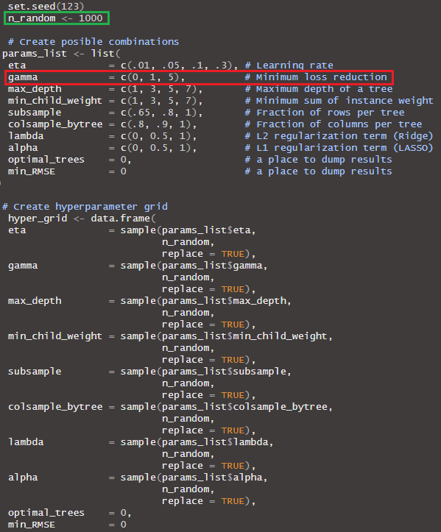
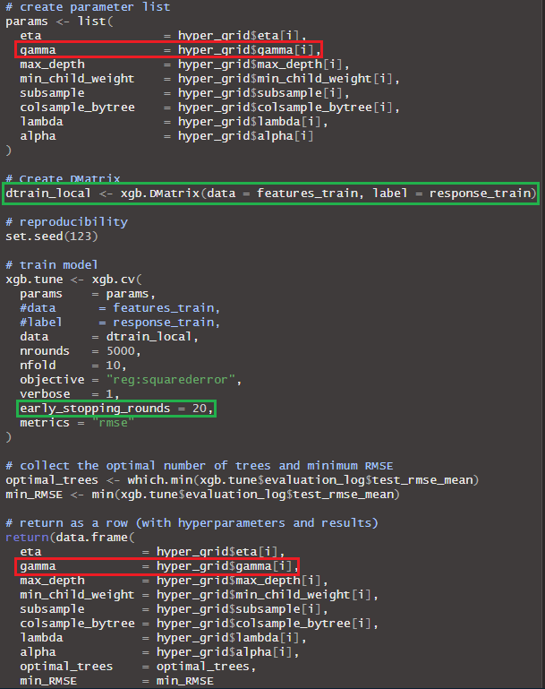
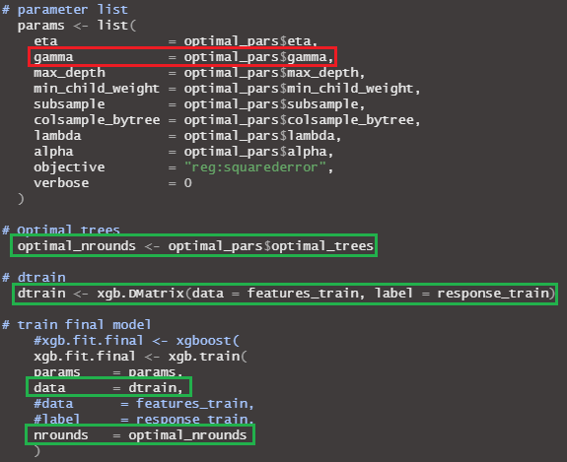c

Data: TTS
Validation Method: Hold – Out 70 – 30
Model: XGBoost
Location: NO
Gamma: SI
Random Search: 1000/15,552
PARALLELISED CODE
nrounds: 5000
early_stopping_rounds :20
TRAIN FINAL MODEL
nrounds: Optimal trees
early_stopping_rounds: NO

METRIC | Non-spatial |  | Queen |  | Knn
 | Training | Test | Training | Test | Training | Test
RMSE | 0.049 | 0.080 | 0.028 | 0.078 | 0.053 | 0.076
Pearson Correlation | 0.874 | 0.345 | 0.966 | 0.412 | 0.843 | 0.427
Spearman_ Correlation | 0.780 | 0.583 | 0.889 | 0.590 | 0.775 | 0.640
Standar deviation | 0.049 | 0.080 | 0.028 | 0.077 | 0.053 | 0.076
r squared | 0.712 | 0.020 | 0.908 | 0.084 | 0.664 | 0.122

 | eta | gamma | max_depth | min_child_weight | subsample | colsample_bytree | lambda | alpha | optimal_trees | min_RMSE
N | 0.1 | 0 | 3 | 1 | 1 | 0.9 | 1 | 0.5 | 170 | 0.07874684
Q | 0.05 | 0 | 7 | 5 | 0.8 | 1 | 1 | 0.5 | 245 | 0.07732515
K | 0.01 | 0 | 3 | 5 | 1 | 0.9 | 0.5 | 0 | 701 | 0.07472564

Data: Phone 05
Validation Method: Hold – Out 70 – 30
Model: XGBoost
Location: NO
Gamma: SI
Random Search: 1000/15,552
PARALLELISED CODE
nrounds: 5000
early_stopping_rounds :20
TRAIN FINAL MODEL
nrounds: Optimal trees
early_stopping_rounds: NO

METRIC | Non-spatial |  | Queen |  | Knn
 | Training | Test | Training | Test | Training | Test
RMSE | 0.000 | 0.001 | 0.001 | 0.001 | 0.001 | 0.001
Pearson Correlation | 0.989 | 0.876 | 0.979 | 0.882 | 0.958 | 0.877
Spearman_ Correlation | 0.973 | 0.872 | 0.960 | 0.872 | 0.926 | 0.870
Standar deviation | 0.000 | 0.001 | 0.001 | 0.001 | 0.001 | 0.001
r squared | 0.977 | 0.767 | 0.958 | 0.777 | 0.916 | 0.769

 | eta | gamma | max_depth | min_child_weight | subsample | colsample_bytree | lambda | alpha | optimal_trees | min_RMSE
N | 0.01 | 0 | 5 | 1 | 0.65 | 1 | 0 | 0 | 1084 | 0.00139619
Q | 0.01 | 0 | 7 | 3 | 0.65 | 1 | 0.5 | 0 | 939 | 0.0013258
K | 0.05 | 0 | 3 | 3 | 0.65 | 0.9 | 0 | 0 | 170 | 0.00133418

Data: TTS
Validation Method: Hold – Out 70 – 30
Model: XGBoost
Location: NO
Gamma: NO
Grid Search:5184
PARALLELISED CODE
nrounds: 5000
early_stopping_rounds :20
TRAIN FINAL MODEL
nrounds: Optimal trees
early_stopping_rounds: NO

METRIC | Non-spatial |  | Queen |  | Knn
 | Training | Test | Training | Test | Training | Test
RMSE | 0.039 | 0.080 | 0.037 | 0.077 | 0.047 | 0.076
Pearson Correlation | 0.929 | 0.348 | 0.936 | 0.394 | 0.880 | 0.438
Spearman_ Correlation | 0.825 | 0.580 | 0.842 | 0.574 | 0.791 | 0.650
Standar deviation | 0.039 | 0.080 | 0.037 | 0.077 | 0.047 | 0.076
r squared | 0.817 | 0.030 | 0.835 | 0.102 | 0.734 | 0.120

 | eta | max_depth | min_child_weight | subsample | colsample_bytree | lambda | alpha | optimal_trees | min_RMSE
N | 0.05 | 7 | 7 | 0.65 | 0.8 | 0 | 0.5 | 184 | 0.07836775
Q | 0.01 | 7 | 7 | 1 | 0.9 | 1 | 0.5 | 70 | 0.07698234
K | 0.05 | 3 | 5 | 1 | 0.8 | 1 | 0 | 218 | 0.07467771

Data: Phone 05
Validation Method: Hold – Out 70 – 30
Model: XGBoost
Location: NO
Gamma: NO
Grid Search:5184
PARALLELISED CODE
nrounds: 5000
early_stopping_rounds :20
TRAIN FINAL MODEL
nrounds: Optimal trees
early_stopping_rounds: NO

METRIC | Non-spatial |  | Queen |  | Knn
 | Training | Test | Training | Test | Training | Test
RMSE | 0.000 | 0.001 | 0.000 | 0.001 | 0.001 | 0.001
Pearson Correlation | 0.989 | 0.883 | 0.990 | 0.882 | 0.984 | 0.885
Spearman_ Correlation | 0.978 | 0.876 | 0.979 | 0.875 | 0.965 | 0.879
Standar deviation | 0.000 | 0.001 | 0.000 | 0.001 | 0.001 | 0.001
r squared | 0.978 | 0.780 | 0.979 | 0.778 | 0.966 | 0.783

 | eta | max_depth | min_child_weight | subsample | colsample_bytree | lambda | alpha | optimal_trees | min_RMSE
N | 0.01 | 7 | 3 | 0.65 | 0.8 | 0 | 0 | 907 | 0.001379816
Q | 0.01 | 7 | 3 | 0.65 | 0.8 | 0 | 0 | 925 | 0.001317209
K | 0.01 | 5 | 3 | 0.8 | 0.8 | 0 | 0 | 894 | 0.07836775

Data: TTS
Validation Method: Blocked CV (K = 5)
Model: XGBoost
Location: NO
Gamma: NO
Grid Search:5184
PARALLELISED CODE
nrounds: 5000
early_stopping_rounds :20
TRAIN FINAL MODEL
nrounds: Optimal trees
early_stopping_rounds: NO

METRIC | Non-spatial |  | Queen |  | Knn
 | Training | Test | Training | Test | Training | Test
RMSE | 0.059 | 0.080 | 0.052 | 0.077 | 0.052 | 0.076
Pearson Correlation | 0.779 | 0.345 | 0.831 | 0.413 | 0.810 | 0.438
Spearman Correlation | 0.733 | 0.564 | 0.759 | 0.603 | 0.771 | 0.621
Standar deviation | 0.059 | 0.080 | 0.052 | 0.078 | 0.052 | 0.076
r squared | 0.554 | 0.107 | 0.646 | 0.152 | 0.637 | 0.176
SD RMSE | 0.006 | 0.014 | 0.004 | 0.011 | 0.013 | 0.011

 | eta | max_depth | min_child_weight | subsample | colsample_bytree | lambda | alpha | optimal_trees | min_RMSE
N
Q
K

Data: Phone 05
Validation Method: Blocked CV (K = 5)
Model: XGBoost
Location: NO
Gamma: NO
Grid Search:5184
PARALLELISED CODE
nrounds: 5000
early_stopping_rounds :20
TRAIN FINAL MODEL
nrounds: Optimal trees
early_stopping_rounds: NO

METRIC | Non-spatial |  | Queen |  | Knn
 | Training | Test | Training | Test | Training | Test
RMSE | 0.000 | 0.001 | 0.000 | 0.001 | 0.000 | 0.001
Pearson Correlation | 0.974 | 0.824 | 0.971 | 0.836 | 0.979 | 0.845
Spearman Correlation | 0.954 | 0.842 | 0.949 | 0.843 | 0.963 | 0.852
Standar deviation | 0.000 | 0.001 | 0.000 | 0.001 | 0.000 | 0.001
r squared | 0948 | 0.648 | 0.942 | 0.677 | 0.958 | 0.696
SD RMSE | 0.000 | 0.000 | 0.000 | 0.000 | 0.000 | 0.000

 | eta | max_depth | min_child_weight | subsample | colsample_bytree | lambda | alpha | optimal_trees | min_RMSE
N
Q
K

Data: TTS
Validation Method: Blocked CV (K = 5)
Model: XGBoost
Location: NO
Gamma: NO
Random Search: 1000/5184
PARALLELISED CODE
nrounds: 5000
early_stopping_rounds :20
TRAIN FINAL MODEL
nrounds: Optimal trees
early_stopping_rounds: NO

METRIC | Non-spatial |  | Queen |  | Knn
 | Training | Test | Training | Test | Training | Test
RMSE | 0.067 | 0.080 | 0.052 | 0.078 | 0.052 | 0.075
Pearson Correlation | 0.659 | 0.324 | 0.808 | 0.406 | 0.826 | 0.466
Spearman Correlation | 0.696 | 0.559 | 0.764 | 0.607 | 0.769 | 0.645
Standar deviation | 0.067 | 0.080 | 0.052 | 0.078 | 0.052 | 0.075
r squared | 0.413 | 0.095 | 0.628 | 0.149 | 0.641 | 0.209
SD RMSE | 0.009 | 0.013 | 0.013 | 0.013 | 0.006 | 0.012

 | eta | max_depth | min_child_weight | subsample | colsample_bytree | lambda | alpha | optimal_trees | min_RMSE
N
Q
K

Data: Phone 05
Validation Method: Blocked CV (K = 5)
Model: XGBoost
Location: NO
Gamma: NO
Random Search: 1000/5184
PARALLELISED CODE
nrounds: 5000
early_stopping_rounds :20
TRAIN FINAL MODEL
nrounds: Optimal trees
early_stopping_rounds: NO

METRIC | Non-spatial |  | Queen |  | Knn
 | Training | Test | Training | Test | Training | Test
RMSE | 0.000 | 0.001 | 0.000 | 0.001 | 0.000 | 0.001
Pearson Correlation | 0.977 | 0.823 | 0.977 | 0.841 | 0.967 | 0.846
Spearman Correlation | 0.955 | 0.838 | 0.957 | 0.845 | 0.946 | 0.851
Standar deviation | 0.000 | 0.001 | 0.000 | 0.001 | 0.000 | 0.001
r squared | 0.953 | 0.649 | 0.953 | 0.678 | 0.935 | 0.694
SD RMSE | 0.000 | 0.000 | 0.000 | 0.000 | 0.000 | 0.000

 | eta | max_depth | min_child_weight | subsample | colsample_bytree | lambda | alpha | optimal_trees | min_RMSE
N
Q
K

